**Lab # 5: Designing of C# Application Forms**

#### Objective:

To make the windows application forms in C#

#### Scope:

The student shall know the following:

* + SQL Commands.
  + C# Programming
  + Hands-on experience with the above- mentioned concepts.

### Creation of Form in Visual Studio:

Open visual studio 2019, the screen is shown below will appear.

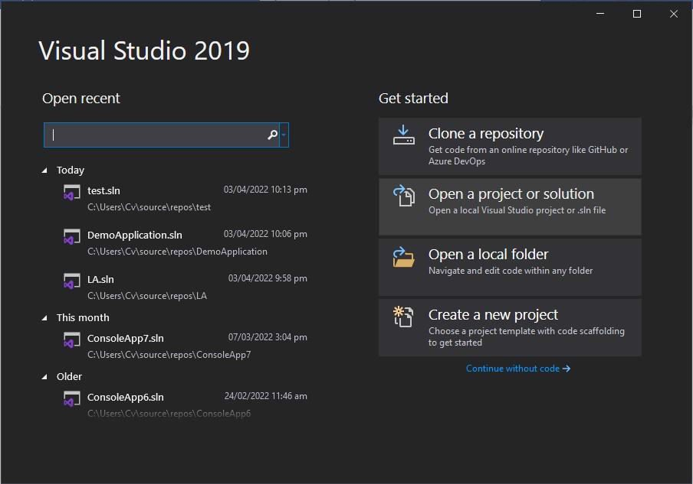

Click on the **Create a new project.** After clicking on that write in the search box **Windows Forms App** as shown on the screen below.

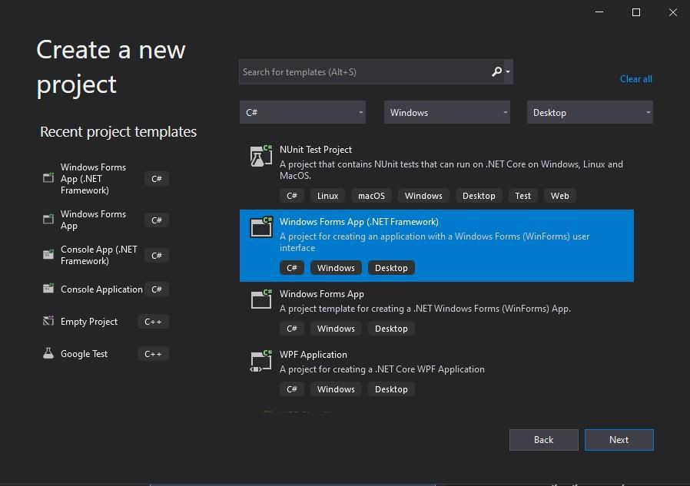

Choose the highlighted option and click on the **Next** button. The screen shown below will appear. Write the name of the form and location and then click on the **Create** button.

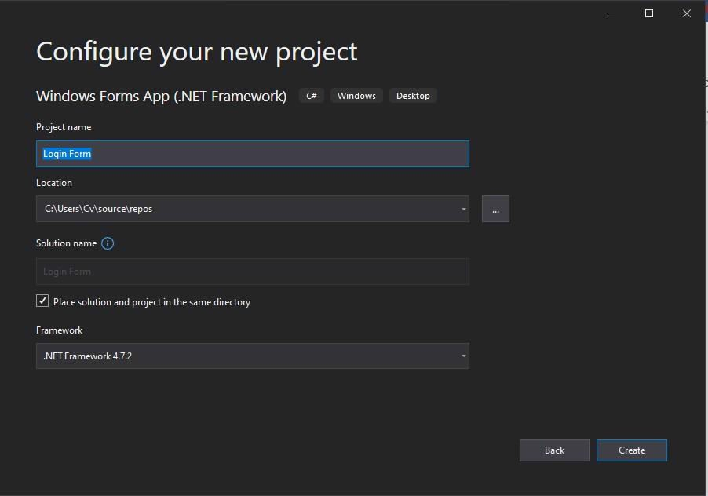

Your blank form is created successfully. You will see the screen as shown below.

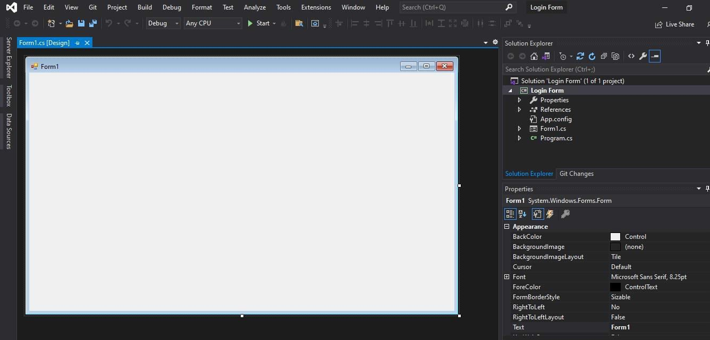

Now you have to create the login form for this insert labels, text boxes, buttons, etc. according to your requirement in the black form. You can insert it from the option on the left of the screen **Toolbox**.

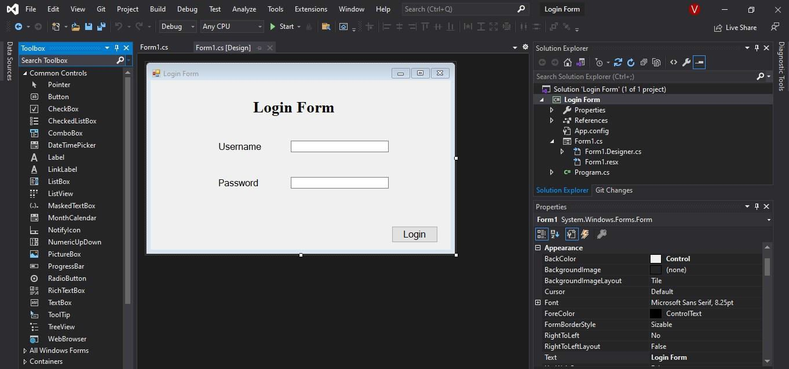

The login form is successfully created by just drag and dropping the required controls. The color, font, and other properties of the form can be changed through the property panel present in the right corner of the visual studio.